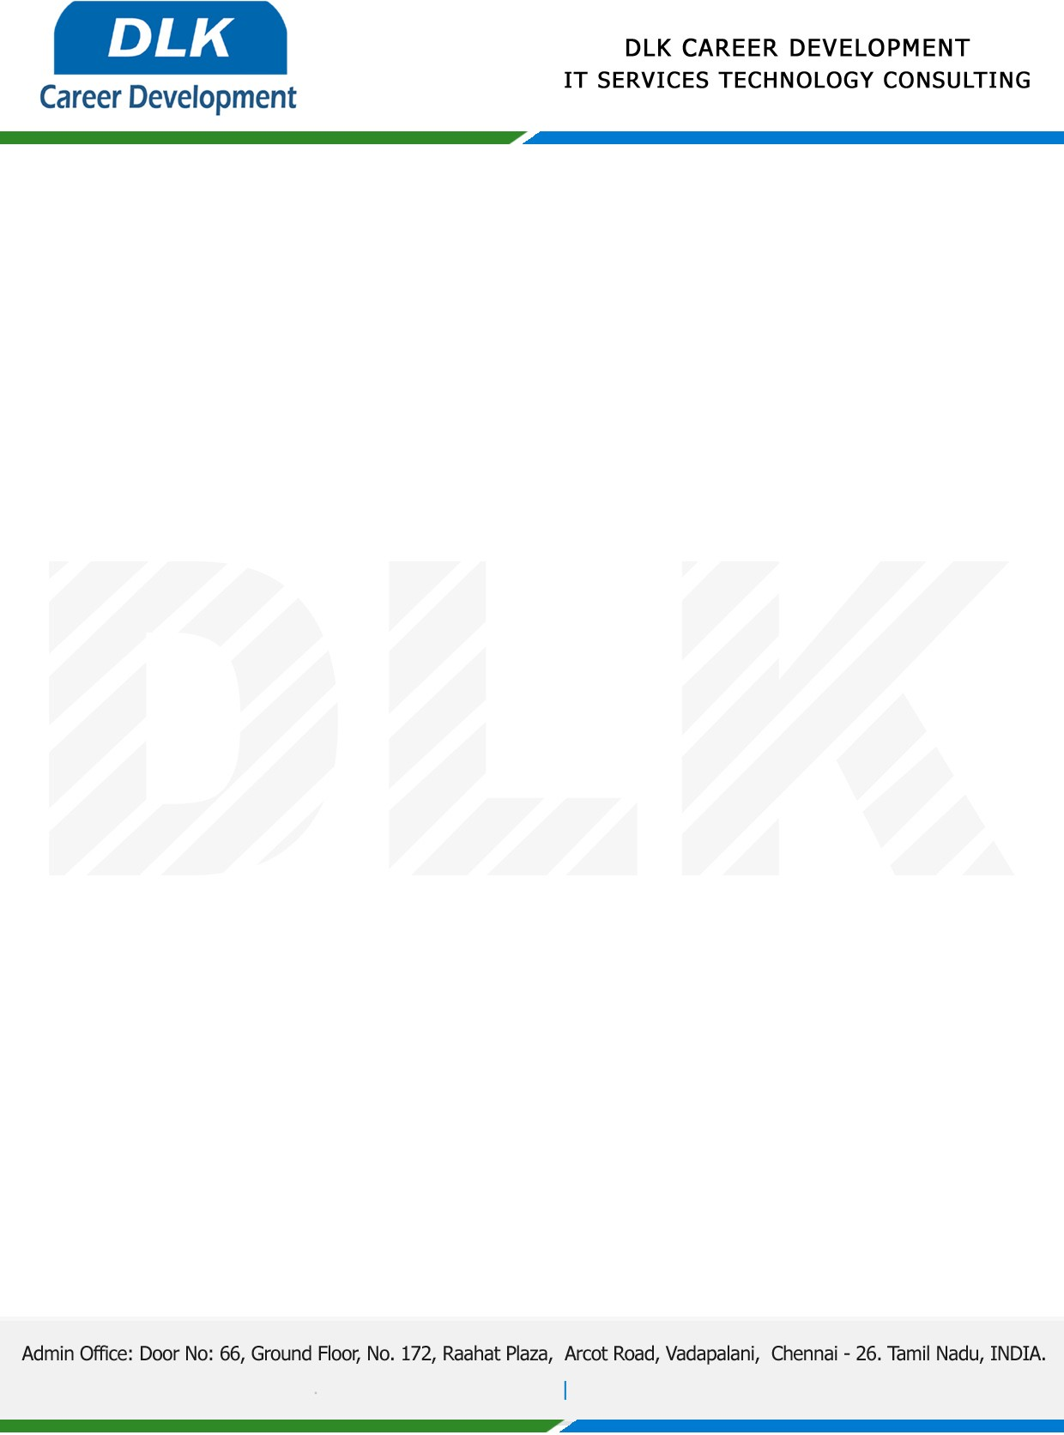

Date: 07 / January/ 2023

**To**

Department of MBA (Human Resources),

Head of Department,

Jerusalem College of Engineering, Chennai- 600100.

**Sub: Letter of Internship Acceptance**

This is to certify that **MS JAYASHOBANA S V (REG NO: 130721631022)** that final year student of has accepted her Internship Work duration from **09th January 2023** to **31st March 2023** under domain **“Human Resource Management”.** During the internship, all information and data collected from you should be kept confidential.

We appreciate your interest in **DLK CAREER DEVELOPMENT**

For **DLK CAREER DEVELOPMENT**

**HR Manager**

**VELMURUGAN J**